EXPERIMENT – 3.

Configuration of topology using Packet Tracer (bus , Ring , hybrid)

1. Bus Topology.

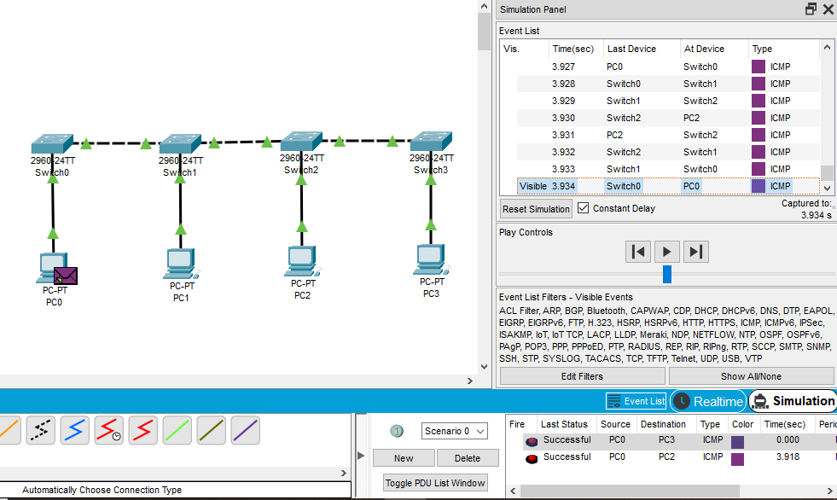

1. Ring Topology.

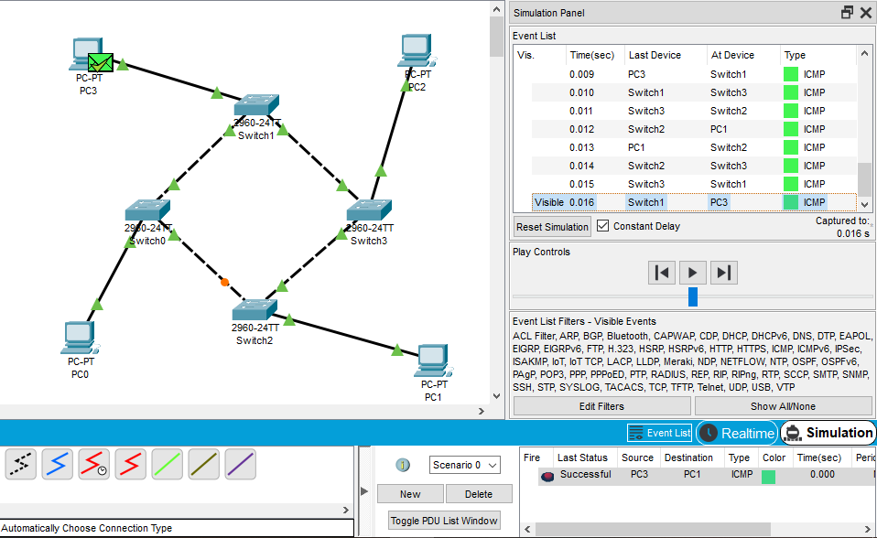

1. Hybrid Topology.

